
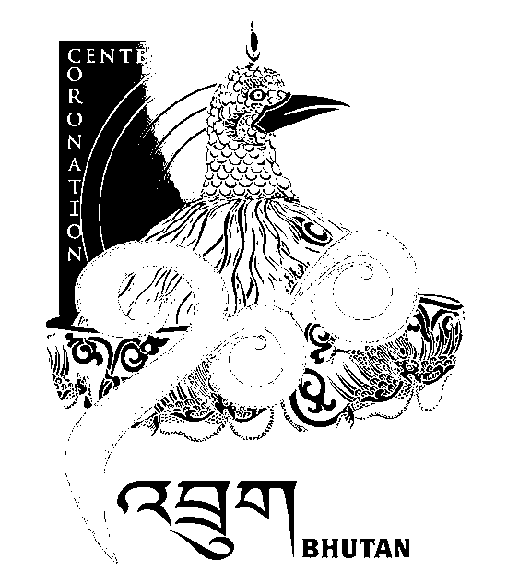
2nd SESSION OF THE FIRST
NATIONAL COUNCIL OF BHUTAN
(18th Sitting)

ORDER OF BUSINESS
(Subject to change without notice)

Monday, 19th January 2009 corresponding to 24th Day of 11th Month of Earth Rat Year
09:30 – 16:00 hrs

09:30 hrs: Pay Homage to His Majesty the Druk Gyalpo

10:00 hrs: Pay Homage to the Fourth Druk Gyalpo

10:30 hrs: Expression of Gratitude to the Government of India

11:00 hrs to 11:30 hrs: TEA BREAK

11:30 hrs: Question Hour with the Ministry of Home & Cultural Affairs

12:00 hrs: Question Hour with the Ministry of Agriculture

12:30 hrs: Question Hour with the Ministry of Labor & Human Resources

13:00 hrs: LUNCH BREAK

14:30 hrs: Amendment of Thromde Act 2007

16:00 hrs: Adjournment of Sitting

National Council Hall Sd/-
16th January 2009
(Tshewang Norbu)
Secretary General

