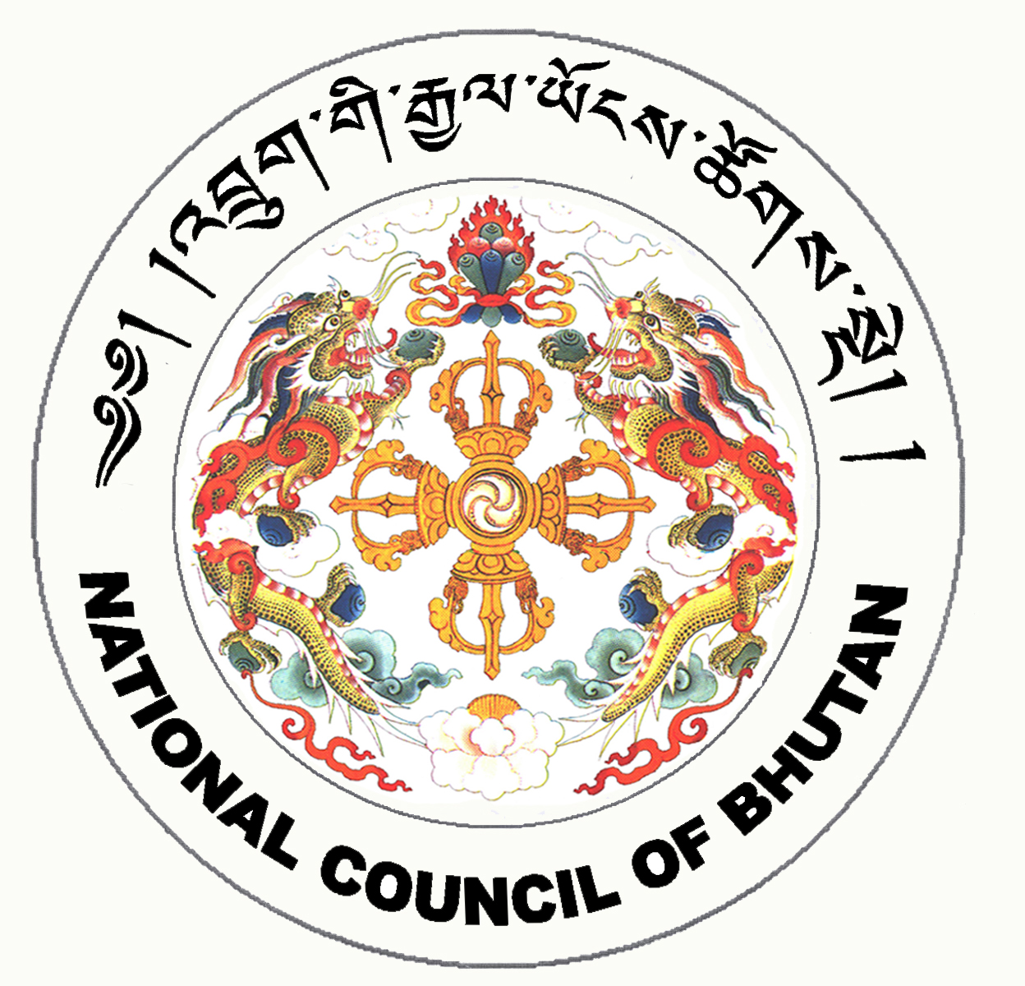
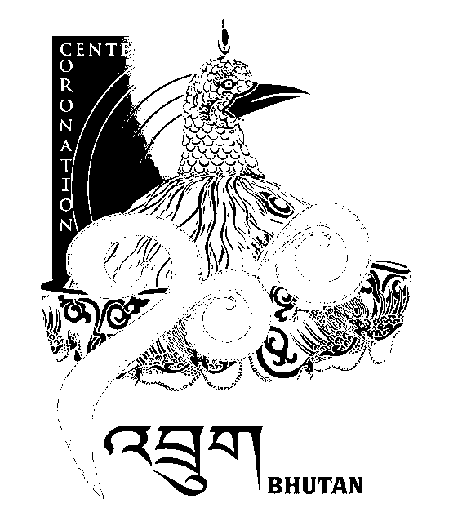
2nd SESSION OF THE FIRST
NATIONAL COUNCIL OF BHUTAN
(14th Sitting)

ORDER OF BUSINESS
(Subject to change without notice)

Tuesday, 13th January 2009 corresponding to 18th Day of 11th Month of Earth Rat Year
09:30 – 13:00 hrs

09:30 hrs: - Ratification of Protocol on Accession of Islamic Republic of Afghanistan to Agreement on South Asian Free Trade Area (SAFTA)

10:30 hrs: - Tabling of Rules of Procedure of the Joint Sitting

- Chairperson of the Legislative Committee, National Council to introduce Rules of Procedure of the Joint Sitting

- Discussion on Rules of Procedure of the Joint Sitting

11:00 hrs to 11:30 hrs: TEA BREAK

11:30 hrs: - Any Other Business (AoB)

13:00 hrs: Adjournment of Sitting

National Council Hall Sd/-
12th January 2009
(Tshewang Norbu)
Secretary General

