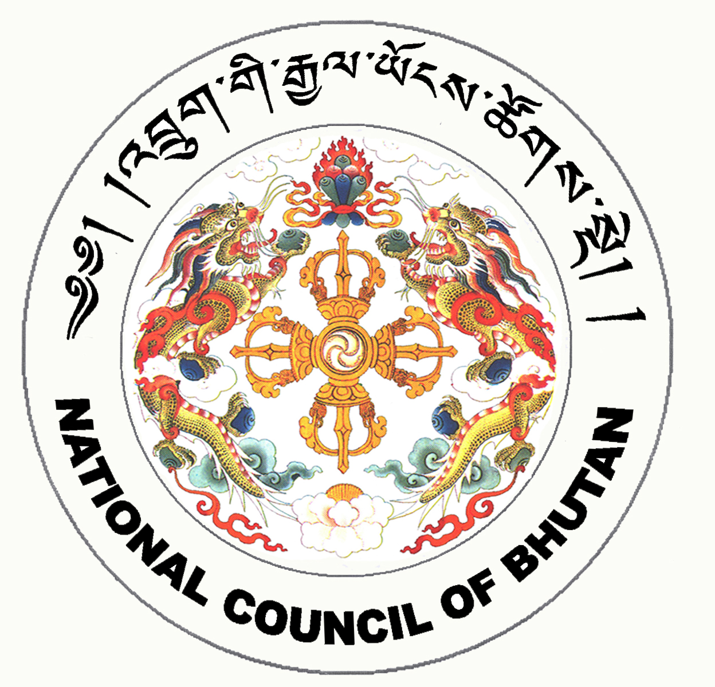

2nd SESSION OF THE FIRST
NATIONAL COUNCIL OF BHUTAN
(12th Sitting)

ORDER OF BUSINESS
(Subject to change without notice)

Friday, 9th January 2009 corresponding to 13th Day of 11th Month of Earth Rat Year
09:30 – 13:00 hrs

09:30 hrs: Discussion on Pending Issues on the Royal Bhutan Police Bill 2008

10:15 hrs: Discussion on Pending Issues on the Prison Bill of the Kingdom of Bhutan 2008

11:00 hrs to 11:30 hrs: TEA BREAK

11:30 hrs: Continuation of Discussion on Role of Party Workers in Governance

13:00 hrs: Adjournment of Sitting

National Council Hall Sd/-
8th January 2009
(Tshewang Norbu)
Secretary General

