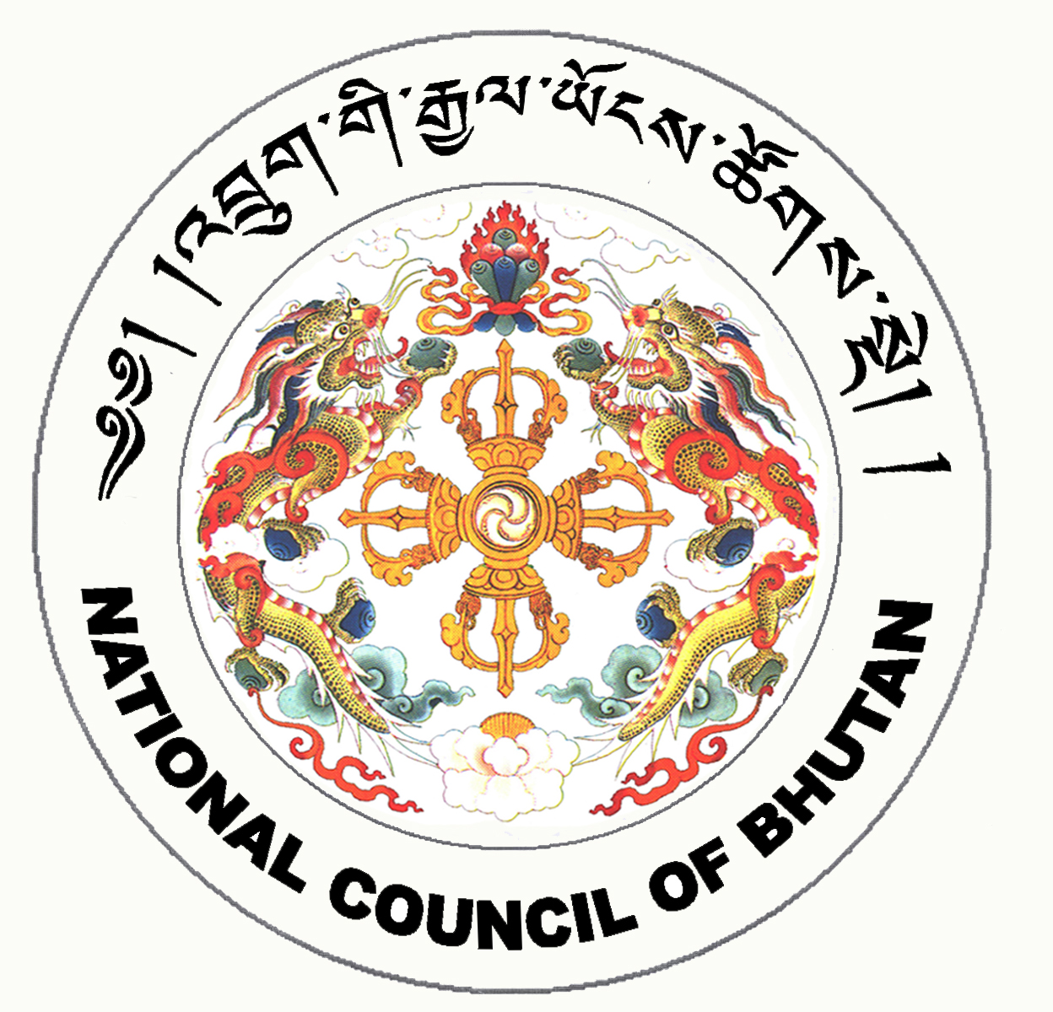
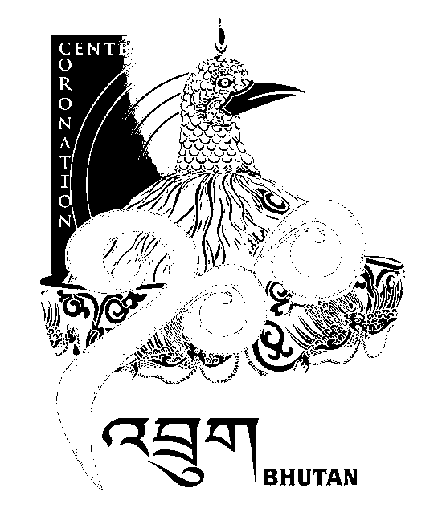
2nd SESSION OF THE FIRST
NATIONAL COUNCIL OF BHUTAN
(11th Sitting)

ORDER OF BUSINESS
(Subject to change without notice)

Thursday, 8th January 2009 corresponding to 12th Day of 11th Month of Earth Rat Year
09:30 – 13:00 hrs

09:30 hrs: Discussion on Constitutional Development Grant

10:15 hrs: Discussion on Local Government Election Campaign Fund

11:00 hrs to 11:30 hrs: TEA BREAK

11:30 hrs: Discussion on Role of Party Workers in Governance

13:00 hrs: Adjournment of Sitting

National Council Hall Sd/-
6th January 2009
(Tshewang Norbu)
Secretary General

