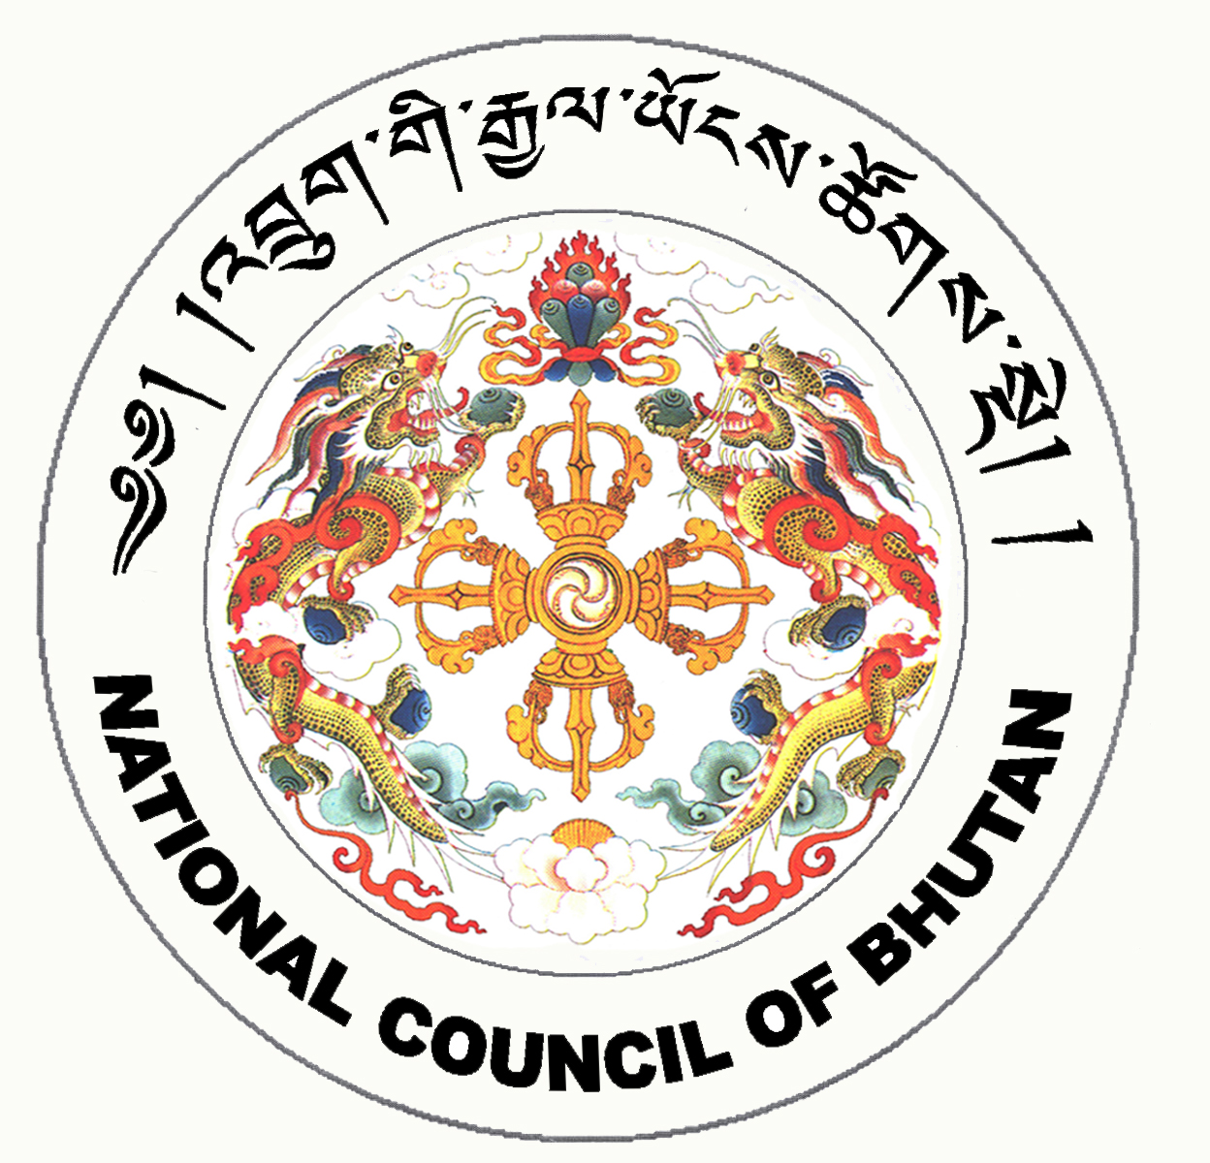

2nd SESSION OF THE FIRST
NATIONAL COUNCIL OF BHUTAN
(7th Sitting)

ORDER OF BUSINESS
(Subject to change without notice)

Thursday, 1st January 2009 corresponding to 5th Day of 11th Month of Earth Rat Year
09:30 – 13:00 hrs

09:30 hrs: Continuation of discussion on the Prison Bill of the Kingdom of Bhutan, 2008

11:00 hrs to 11:30 hrs: TEA BREAK

11:30 hrs: Continuation of discussion on the Prison Bill of the Kingdom of Bhutan, 2008

13:00 hrs: Adjournment of Sitting

National Council Hall Sd/-
30th December 2008
(Tshewang Norbu)
Secretary General

