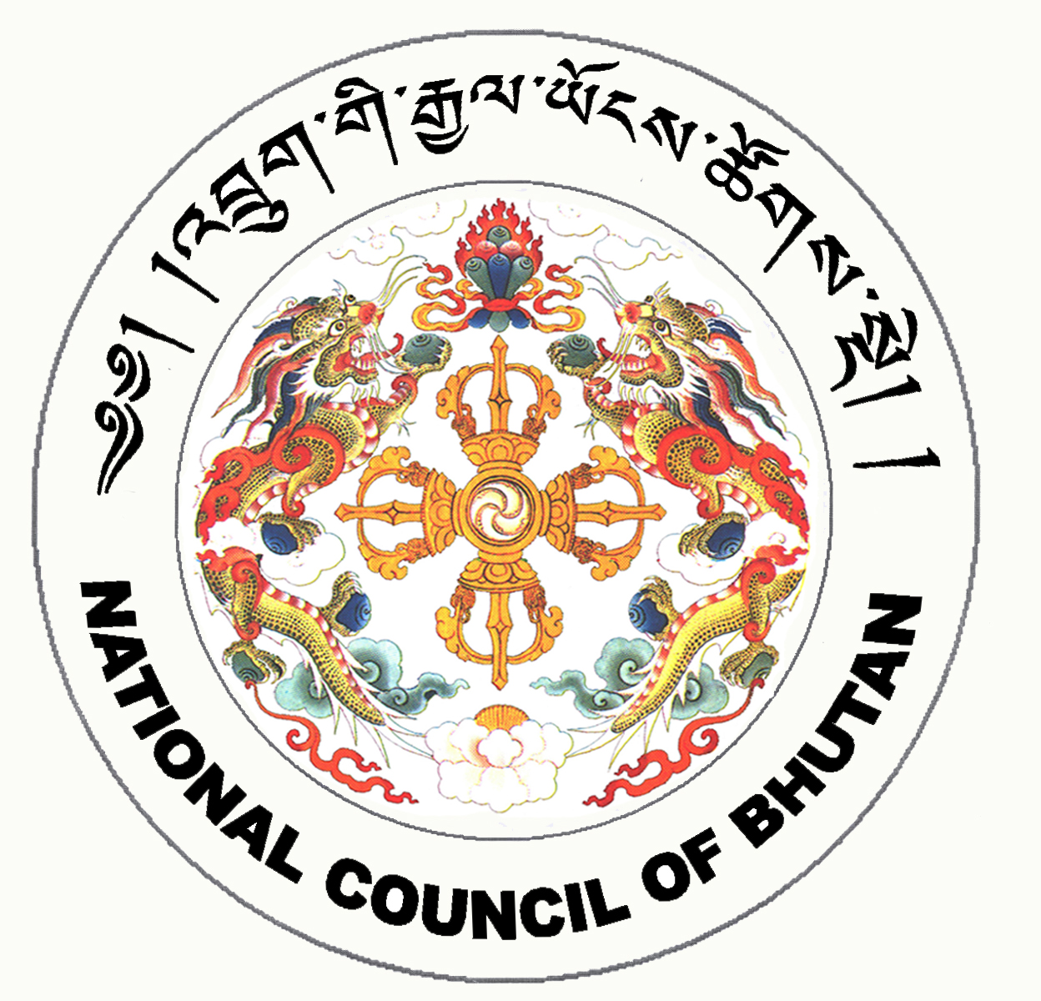

2nd SESSION OF THE FIRST
NATIONAL COUNCIL OF BHUTAN
(6th Sitting)

ORDER OF BUSINESS
(Subject to change without notice)

Wednesday, 31st December 2008 corresponding to 4th Day of 11th Month of Earth Rat Year
09:30 – 13:00 hrs

09:30 hrs: Continuation of discussion on the Royal Bhutan Police Bill, 2008

11:00 hrs to 11:30 hrs: TEA BREAK

11:30 hrs: Tabling of the Prison Bill of the Kingdom of Bhutan, 2008

- Chief of Police to introduce the Prison Bill of the Kingdom of Bhutan, 2008

11:45 hrs: Discussion on the Prison Bill of the Kingdom of Bhutan, 2008

13:00 hrs: Adjournment of Sitting

National Council Hall Sd/-
30th December 2008
(Tshewang Norbu)
Secretary General

