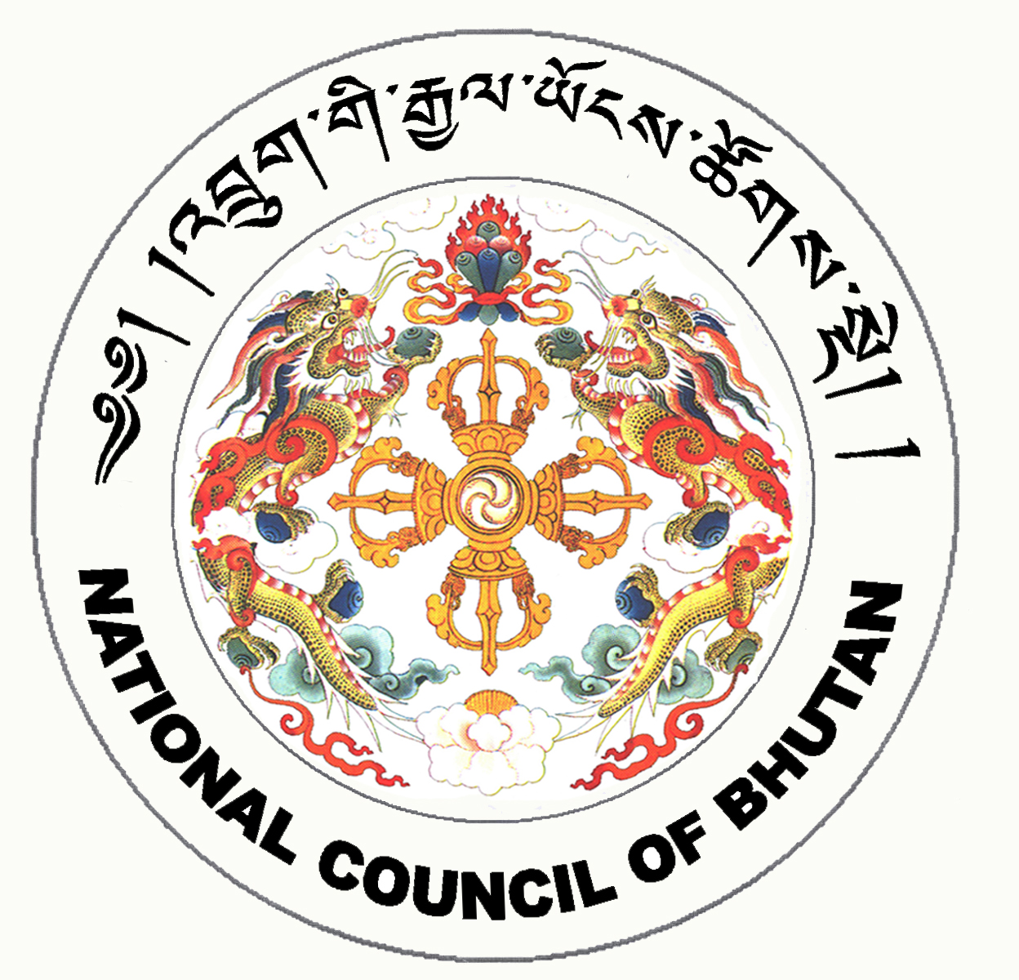

2nd SESSION OF THE FIRST
NATIONAL COUNCIL OF BHUTAN
(5th Sitting)

ORDER OF BUSINESS
(Subject to change without notice)

Tuesday, 30th December 2008 corresponding to 3rd Day of 11th Month of Earth Rat Year
09:30 – 16:00 hrs

09:30 hrs: Continuation of discussion on the Royal Bhutan Police Bill, 2008

11:00 hrs to 11:30 hrs: TEA BREAK

11:30 hrs: Continuation of discussion on the Royal Bhutan Police Bill, 2008

13:00 hrs to 14:30 hrs: LUNCH BREAK

14:30 hrs: Continuation of discussion on the Royal Bhutan Police Bill, 2008

16:00 hrs: Adjournment of Sitting

National Council Hall Sd/-
29th December 2008
(Tshewang Norbu)
Secretary General

