
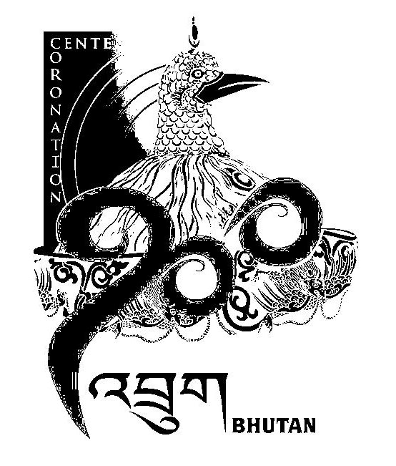
1st SESSION OF THE FIRST
NATIONAL COUNCIL OF BHUTAN
(26th Sitting)

ORDER OF BUSINESS
(Subject to change without notice)

24th July 2008 corresponding to 21st Day of second 5th Month of Earth Rat Year
09:30 – 11.00 hrs

09:30 hrs - Discussion on the agenda of the next National Council Session

10:30 hrs - Recess

10:45 hrs - Reassemble in the Council Hall

10:50 hrs - Hon’ble Chairperson, Secretary General and Hon’ble Members shall stay standing at the front

10:55 hrs - Recital of Tashi Moenlam

11:00 hrs - Secretary General of National Council will offer Dar to the Golden Throne when the recital of Desheg Tenpa commences

National Council Hall Sd/-
23rd July 2008
(Tshewang Norbu)
Secretary General

