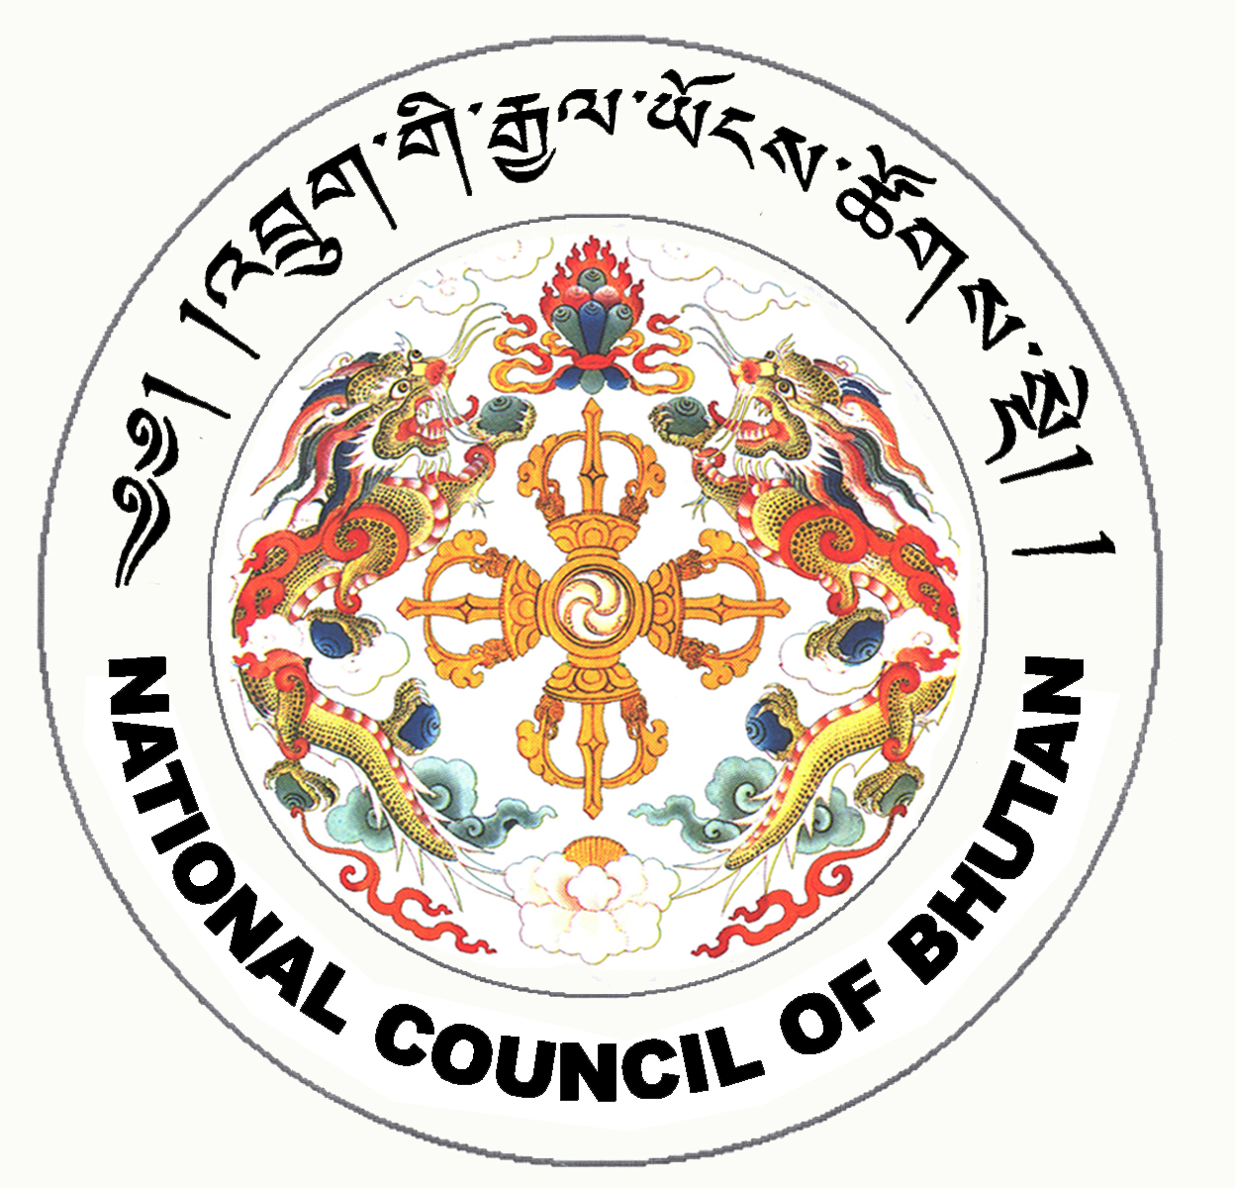
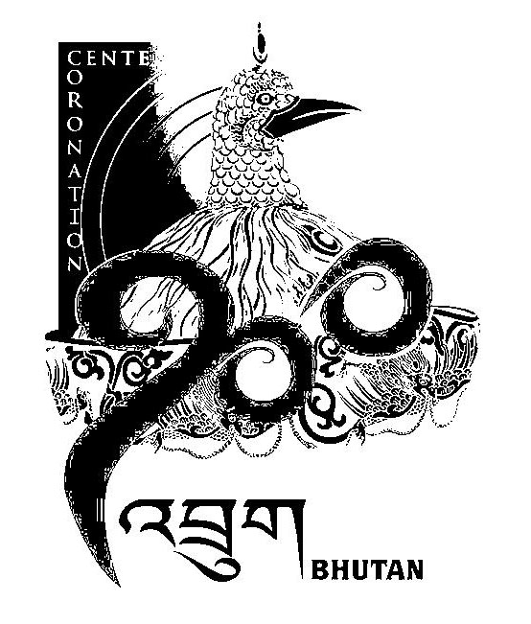
1st SESSION OF THE FIRST
NATIONAL COUNCIL OF BHUTAN
(25th Sitting)

ORDER OF BUSINESS
(Subject to change without notice)

23rd July 2008 corresponding to 20th Day of second 5th Month of Earth Rat Year
09:30 – 13.00 hrs

09:30 hrs - Continue discussion on the Public Election Fund Bill of the Kingdom of Bhutan 2008

11:00 hrs - TEA BREAK

11:30 hrs - Discussion on the amendments and recommendations made by the National Assembly on the Election Bill of the Kingdom of Bhutan 2008

13:00 hrs - Adjournment of Sitting

National Council Hall Sd/-
22nd July 2008
(Tshewang Norbu)
Secretary General

