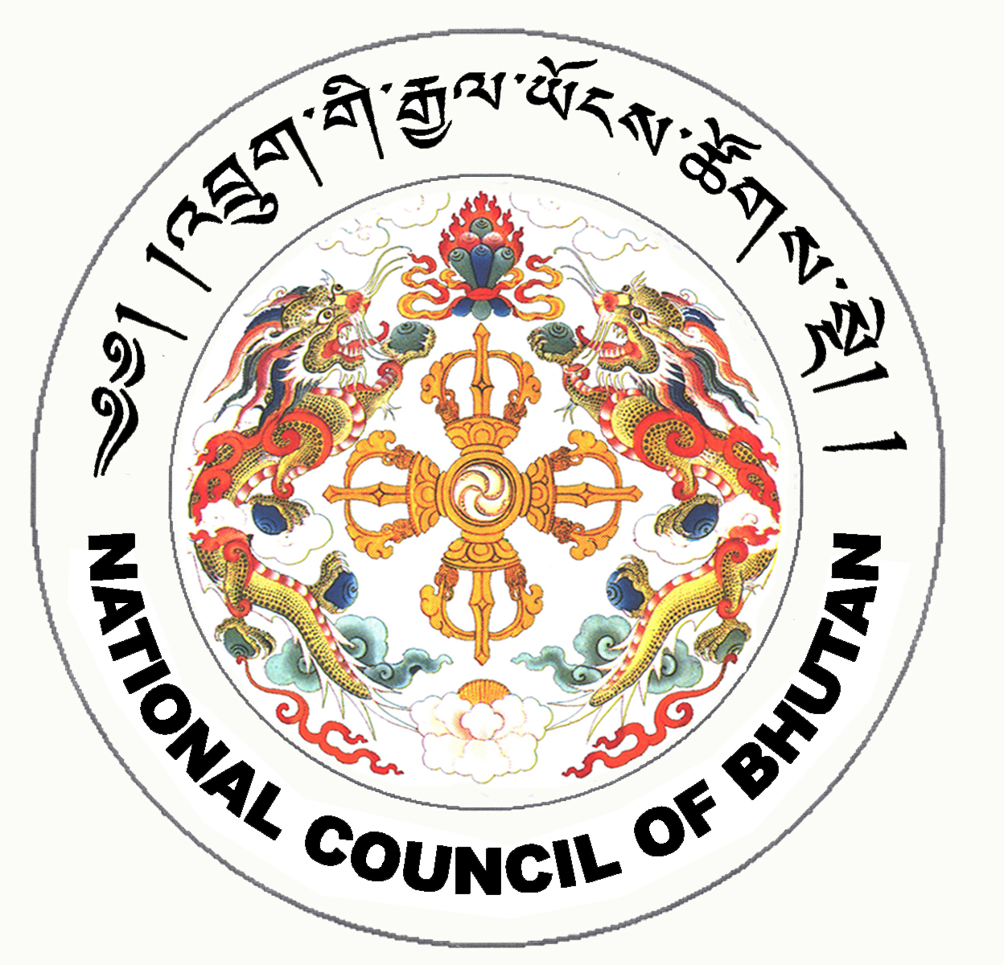

1st SESSION OF THE FIRST
NATIONAL COUNCIL OF BHUTAN
(24th Sitting)

ORDER OF BUSINESS
(Subject to change without notice)

22nd July 2008 corresponding to 19th Day of second 5th Month of Earth Rat Year
09:30 – 13.00 hrs

09:30 hrs - Discussion on the Agreement on Establishing the SAARC Food Bank

- Discussion on the Agreement on Establishment of South Asian University

11:00 hrs - TEA BREAK

11:30 hrs - Continue discussion on the Public Election Fund Bill of the Kingdom of Bhutan 2008

13:00 hrs - Adjournment of Sitting

National Council Hall Sd/-
21st July 2008
(Tshewang Norbu)
Secretary General

