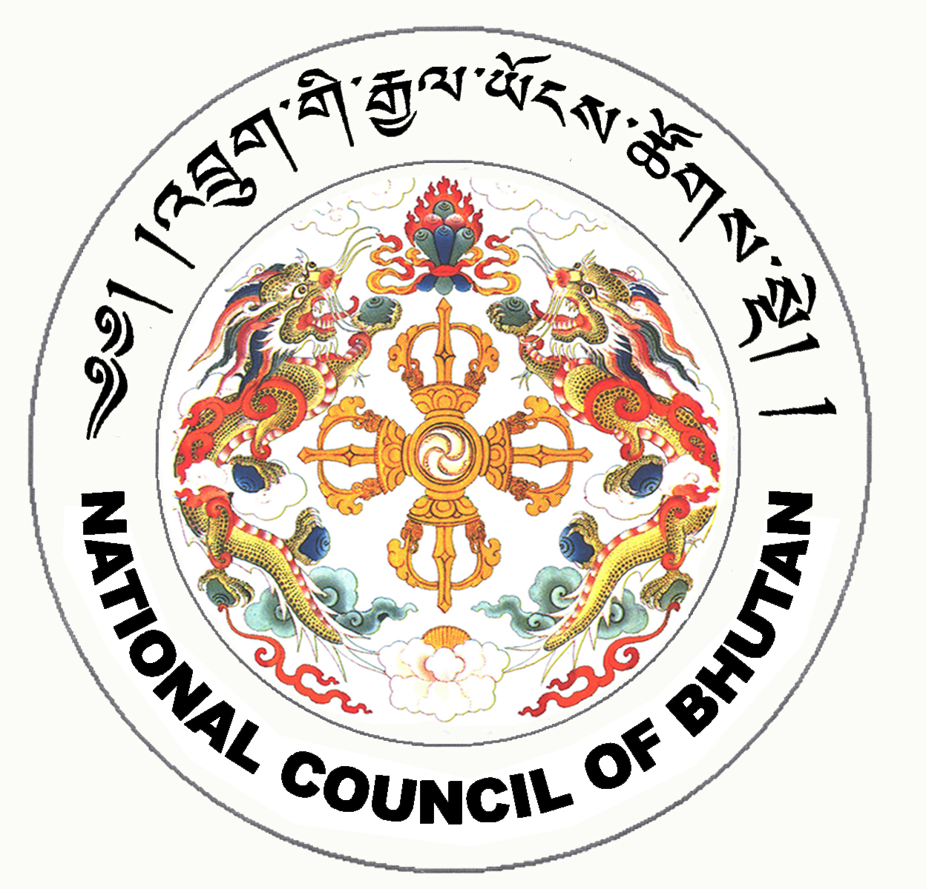
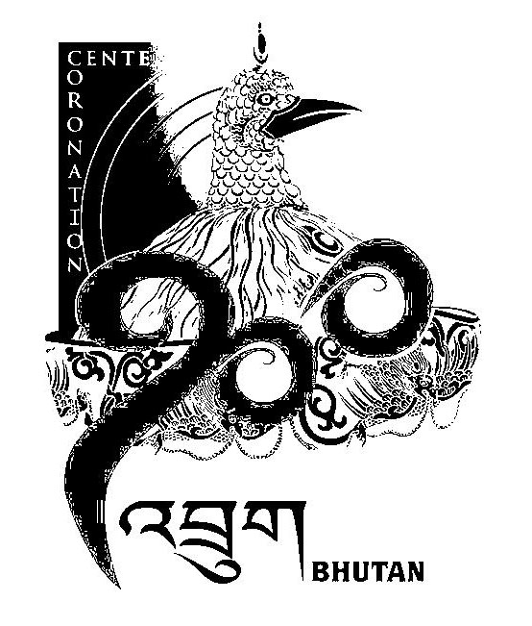
1st SESSION OF THE FIRST
NATIONAL COUNCIL OF BHUTAN
(23rd Sitting)

ORDER OF BUSINESS
(Subject to change without notice)

21st July 2008 corresponding to 18th Day of second 5th Month of Earth Rat Year
09:30 – 13.00 hrs

09:30 hrs - Presentation of the changes and reviews on the National Council Bill of Bhutan 2008 by the National Council Secretariat

11:00 hrs - TEA BREAK

11:30 hrs - Tabling of the Public Election Fund Bill of the Kingdom of Bhutan 2008

- Chief Election Commissioner to take leave of the House to introduce the Public Election Fund Bill of the Kingdom of Bhutan 2008

- Introduction of the Public Election Fund Bill of the Kingdom of Bhutan 2008

13:00 hrs - Adjournment of Sitting

National Council Hall Sd/-
17th July 2008
(Tshewang Norbu)
Secretary General

