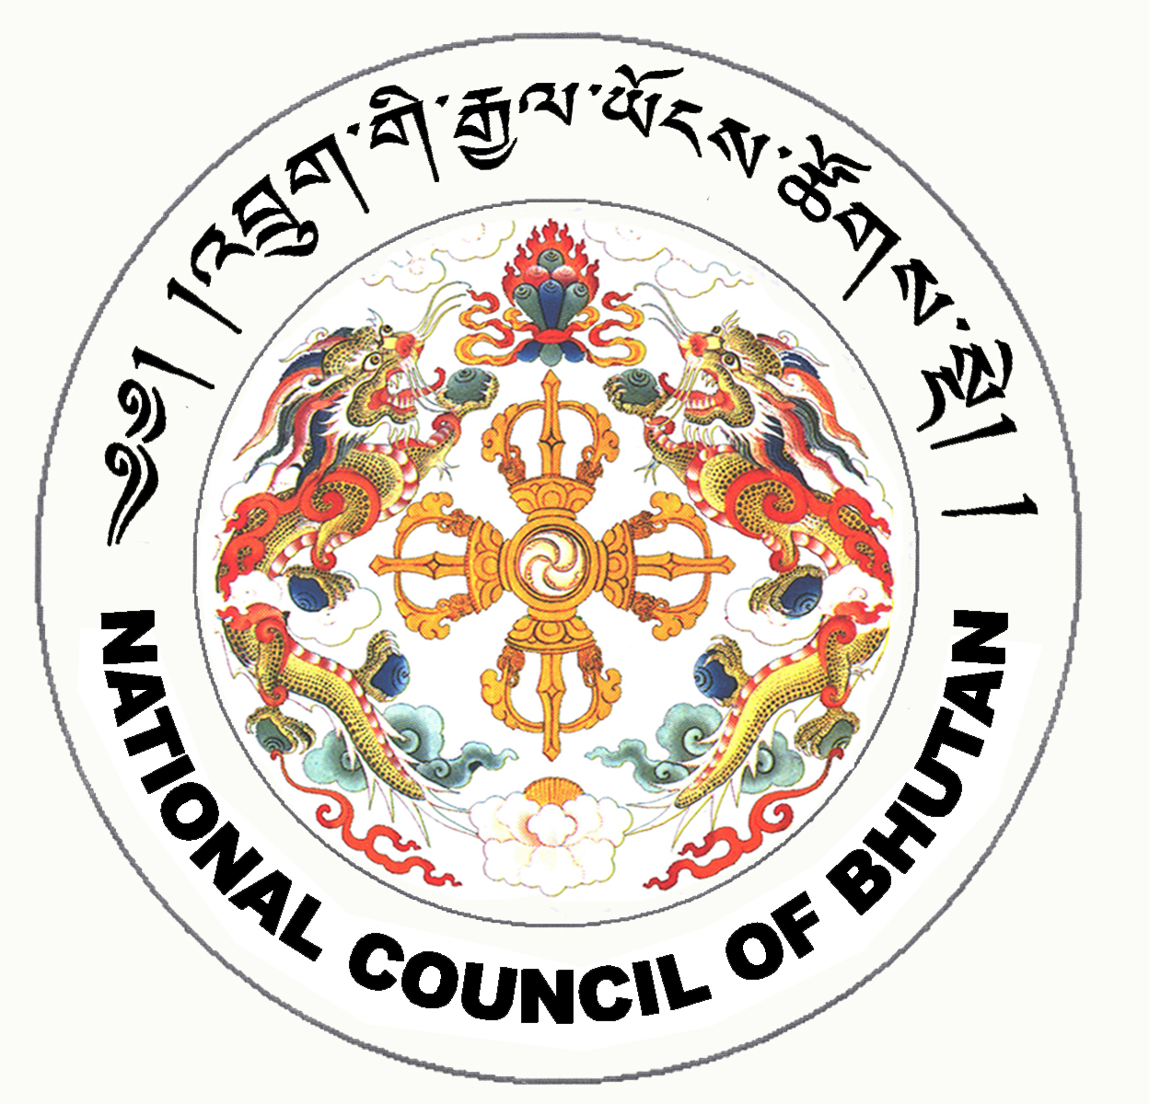

1st SESSION OF THE FIRST
NATIONAL COUNCIL OF BHUTAN
(22nd Sitting)

ORDER OF BUSINESS
(Subject to change without notice)

17th July 2008 corresponding to second 14th Day of second 5th Month of Earth Rat Year
09:30 – 13.00 hrs

09:30 hrs - Continue discussion on the Parliamentary Entitlement Act of Bhutan 2008

11:00 hrs - TEA BREAK

11:30 hrs - Presentation of the changes and reviews on the National Assembly Bill of Bhutan 2008 by the National Assembly Secretariat

13:00 hrs - Adjournment of Sitting

National Council Hall Sd/-
16th July 2008
(Tshewang Norbu)
Secretary General

