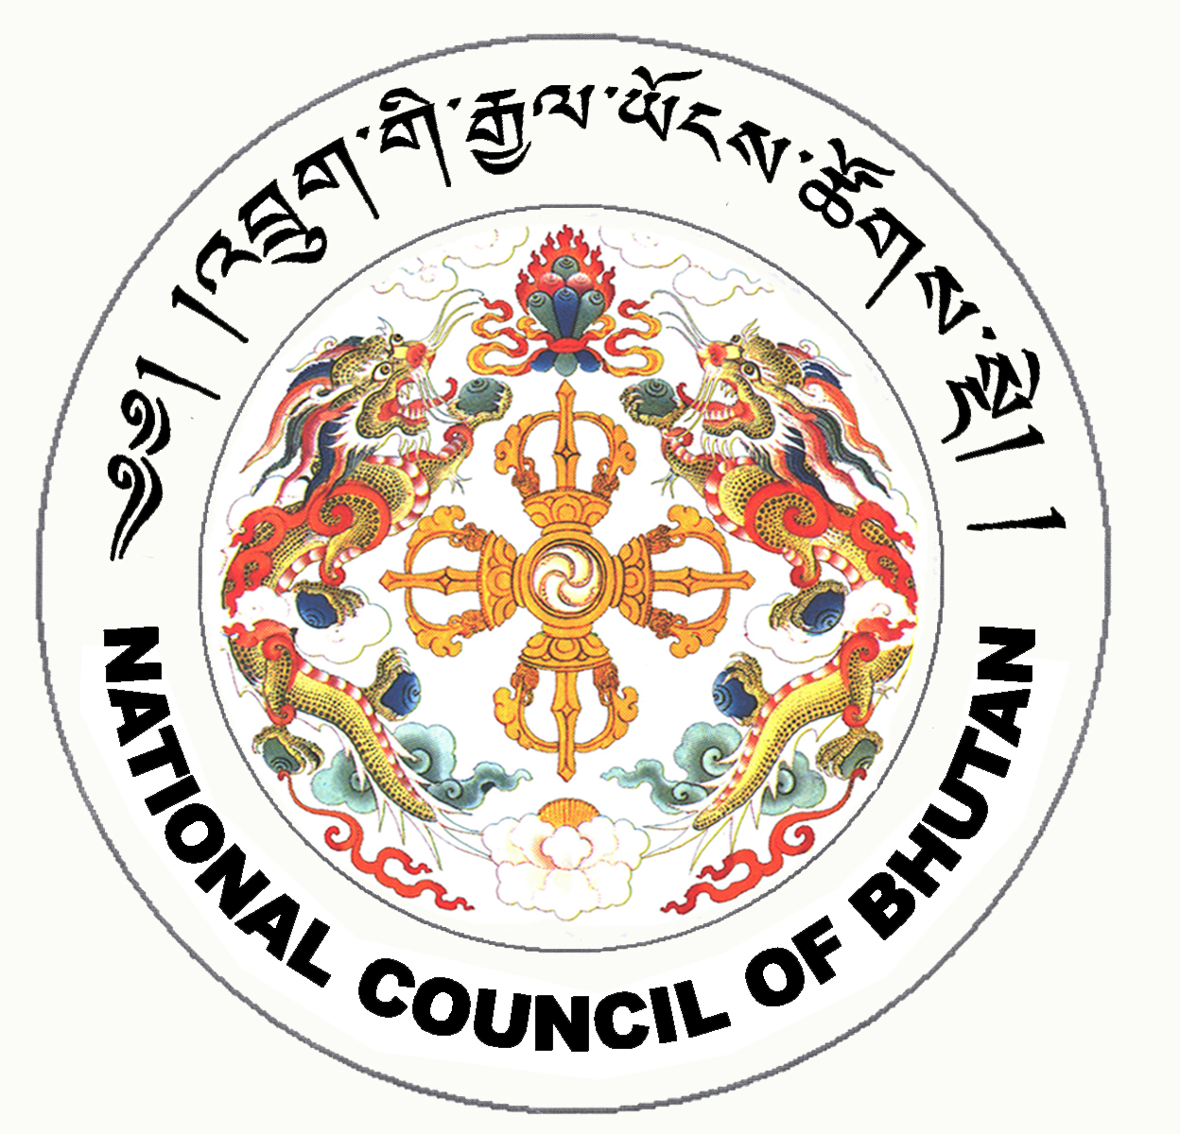

1st SESSION OF THE FIRST
NATIONAL COUNCIL OF BHUTAN
(21st Sitting)

ORDER OF BUSINESS
(Subject to change without notice)

16th July 2008 corresponding to second 13th Day of second 5th Month of Earth Rat Year
09:30 – 13.00 hrs

09:30 hrs - Presentation of the changes and reviews on the National Assembly Bill of Bhutan 2008 by the National Assembly Secretariat

11:00 hrs - TEA BREAK

11:30 hrs - Tabling of the Parliamentary Entitlement Bill of Bhutan 2008

- Leave to introduce the Parliamentary Entitlement Bill of Bhutan 2008

- Introduction of the Parliamentary Entitlement Bill of Bhutan 2008

13:00 hrs - Adjournment of Sitting

National Council Hall Sd/-
15th July 2008
(Tshewang Norbu)
Secretary General

