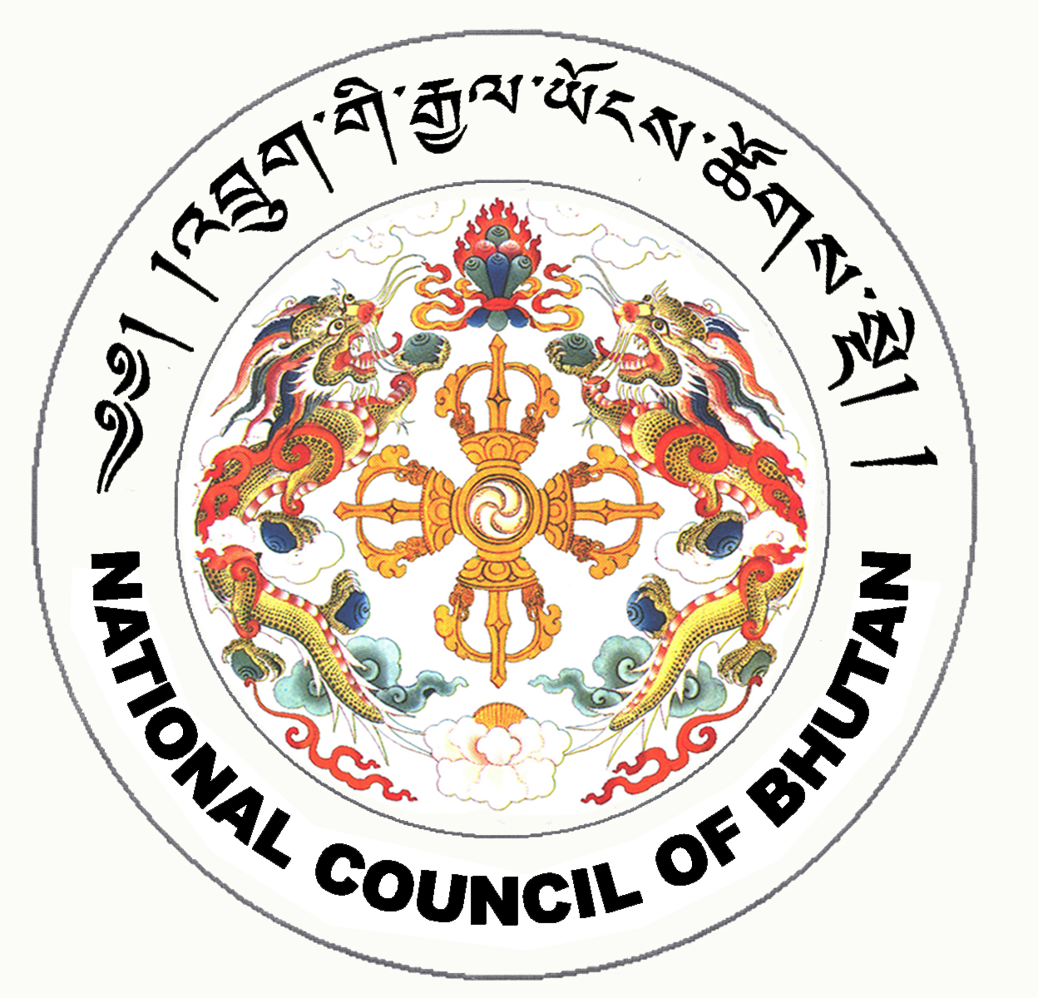

1st SESSION OF THE FIRST
NATIONAL COUNCIL OF BHUTAN
(19th Sitting)

ORDER OF BUSINESS
(Subject to change without notice)

14th July 2008 corresponding to second 11th Day of second 5th Month of Earth Rat Year
09:30 – 13.00 hrs

09:30 hrs - Continue discussion on the National Council Bill of Bhutan 2008

11:00 hrs - TEA BREAK

11:30 hrs - Continue discussion on the National Council Bill of Bhutan 2008

13:00 hrs - Adjournment of Sitting

National Council Hall Sd/-
11th July 2008
(Tshewang Norbu)
Secretary General

