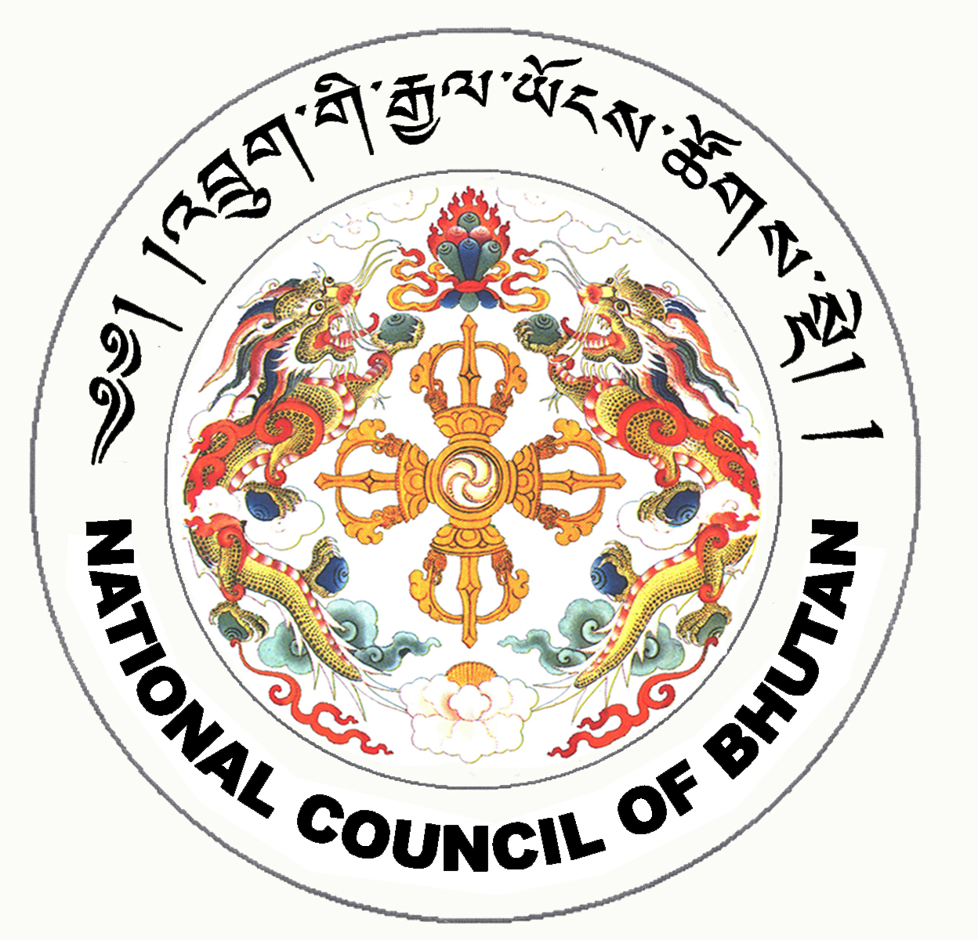

1st SESSION OF THE FIRST
NATIONAL COUNCIL OF BHUTAN
(16th Sitting)

ORDER OF BUSINESS
(Subject to change without notice)

9th July 2008 corresponding to 7th Day of second 5th Month of Earth Rat Year
09:30 – 13.00 hrs

09:30 hrs - Tabling of the National Council Bill of Bhutan 2008

- Secretary General of National Council to take leave to introduce the National Council Bill of Bhutan 2008

- Introduction of the National Council Bill of Bhutan 2008

10:30 hrs - Discussion on the National Council Bill of Bhutan 2008

11:00 hrs - TEA BREAK

11:30 hrs - Continue discussion on the National Council Bill of Bhutan 2008

13:00 hrs - Adjournment of Sitting

National Council Hall Sd/-
8th July 2008
(Tshewang Norbu)
Secretary General

