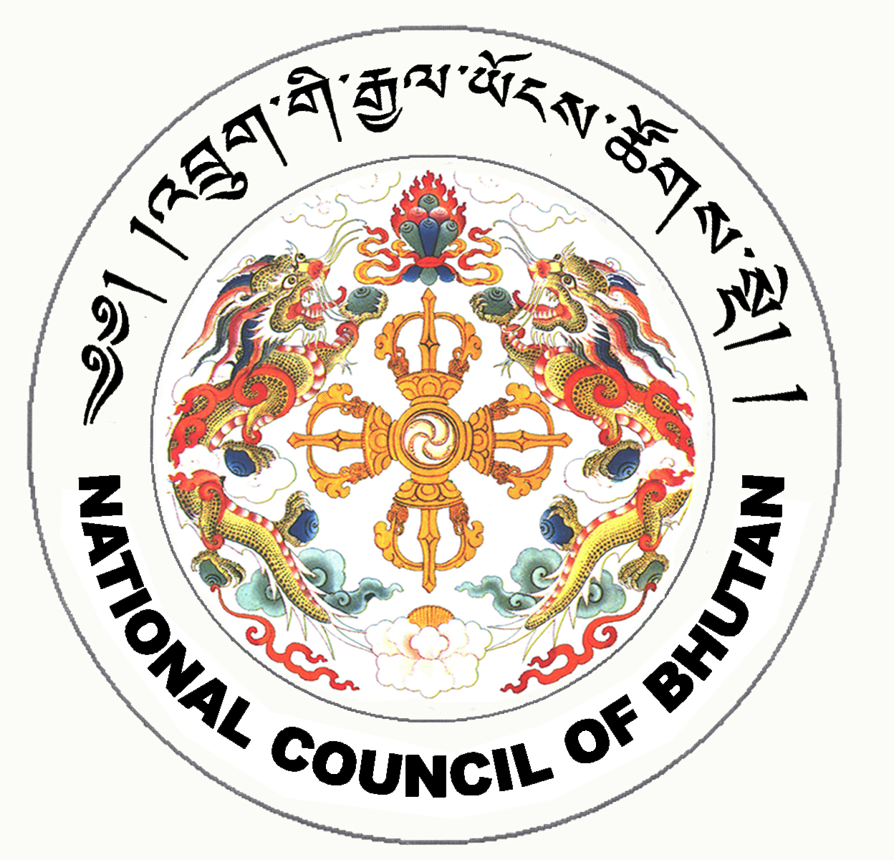

1st SESSION OF THE FIRST
NATIONAL COUNCIL OF BHUTAN
(14th Sitting)

ORDER OF BUSINESS
(Subject to change without notice)

7th July 2008 corresponding to 5th Day of second 5th Month of Earth Rat Year
09:30 – 13.00 hrs

09:30 hrs - Continue presentation of the changes and reviews on the Election Bill of Bhutan 2008 by the Election Commission of Bhutan.

11:00 hrs - TEA BREAK

11:30 hrs - Continue presentation of the changes and reviews on the Election Bill of Bhutan 2008 by the Election Commission of Bhutan.

Presentation of the changes and reviews on the National Referendum Bill of Bhutan 2008 by the Election Commission of Bhutan.

13:00 hrs - Adjournment of Sitting

National Council Hall Sd/-
4th July 2008
(Tshewang Norbu)
Secretary General

