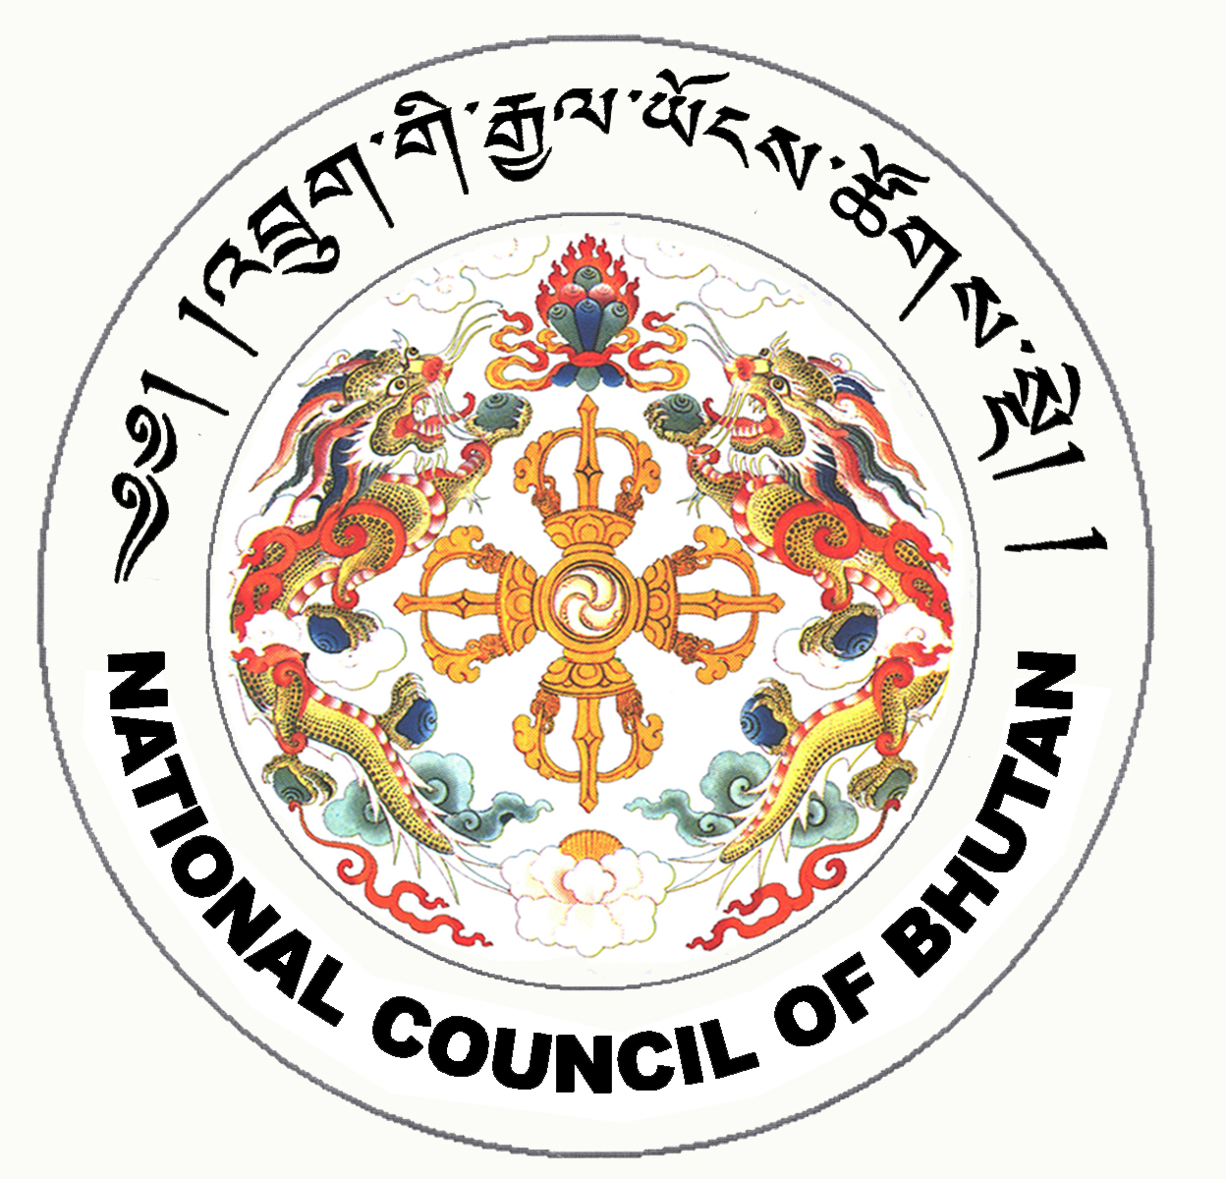
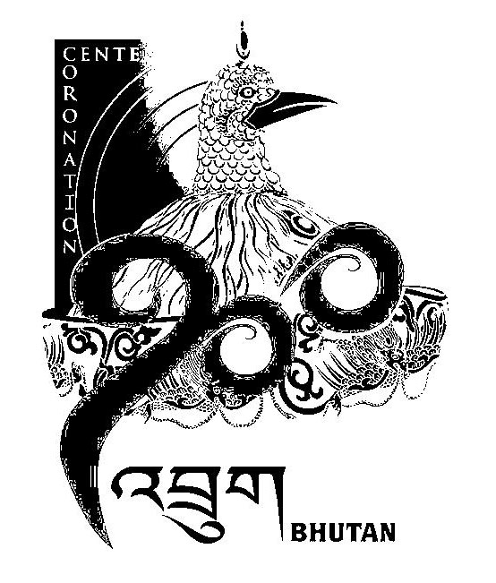
1st SESSION OF THE FIRST
NATIONAL COUNCIL OF BHUTAN
(12th Sitting)

ORDER OF BUSINESS
(Subject to change without notice)

3rd July 2008 corresponding to 30th Day of first 5th Month of Earth Rat Year
09:30 – 13.00 hrs

09:30 hrs - Presentation of the changes and reviews on the Election Bill of Bhutan 2008 by the Election Commission of Bhutan.

11:00 hrs - TEA BREAK

11:30 hrs - Continue presentation of the changes and reviews on the Election Bill of Bhutan 2008 by the Election Commission of Bhutan.

13:00 hrs - Adjournment of Sitting

National Council Hall Sd/-
2nd July 2008
(Tshewang Norbu)
Secretary General

