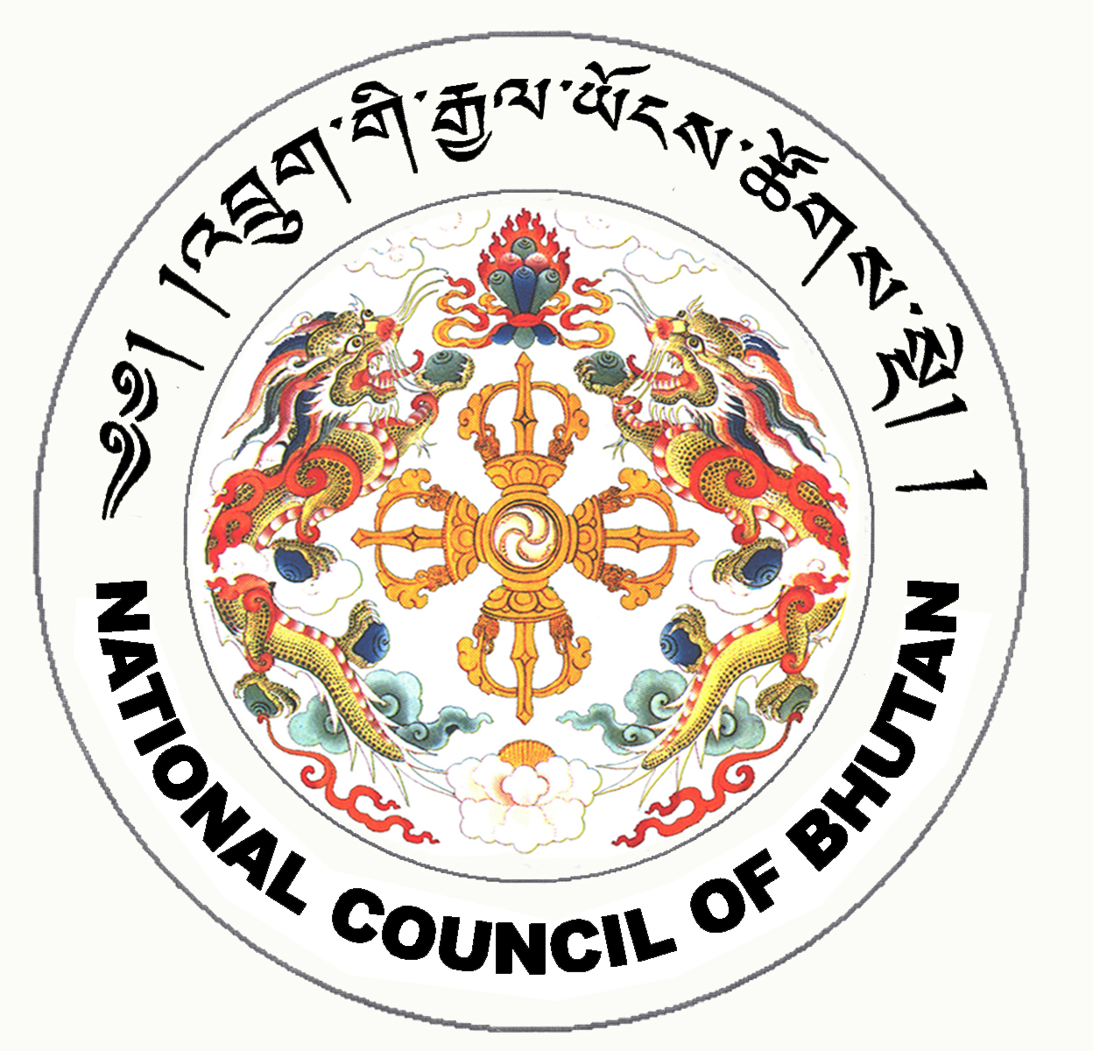

1st SESSION OF THE FIRST
NATIONAL COUNCIL OF BHUTAN
(11th Sitting)

ORDER OF BUSINESS
(Subject to change without notice)

2nd July 2008 corresponding to 29th Day of first 5th Month of Earth Rat Year
09:30 – 13.00 hrs

09:30 hrs - Continue discussion on Budget and Re-appropriation Bill for the Financial Year 2008-2009.

11:00 hrs - TEA BREAK

11:30 hrs - Continue discussion on Budget and Re-appropriation Bill for the Financial Year 2008-2009.

13:00 hrs - Adjournment of Sitting

National Council Hall Sd/-
1st July 2008
(Tshewang Norbu)
Secretary General

