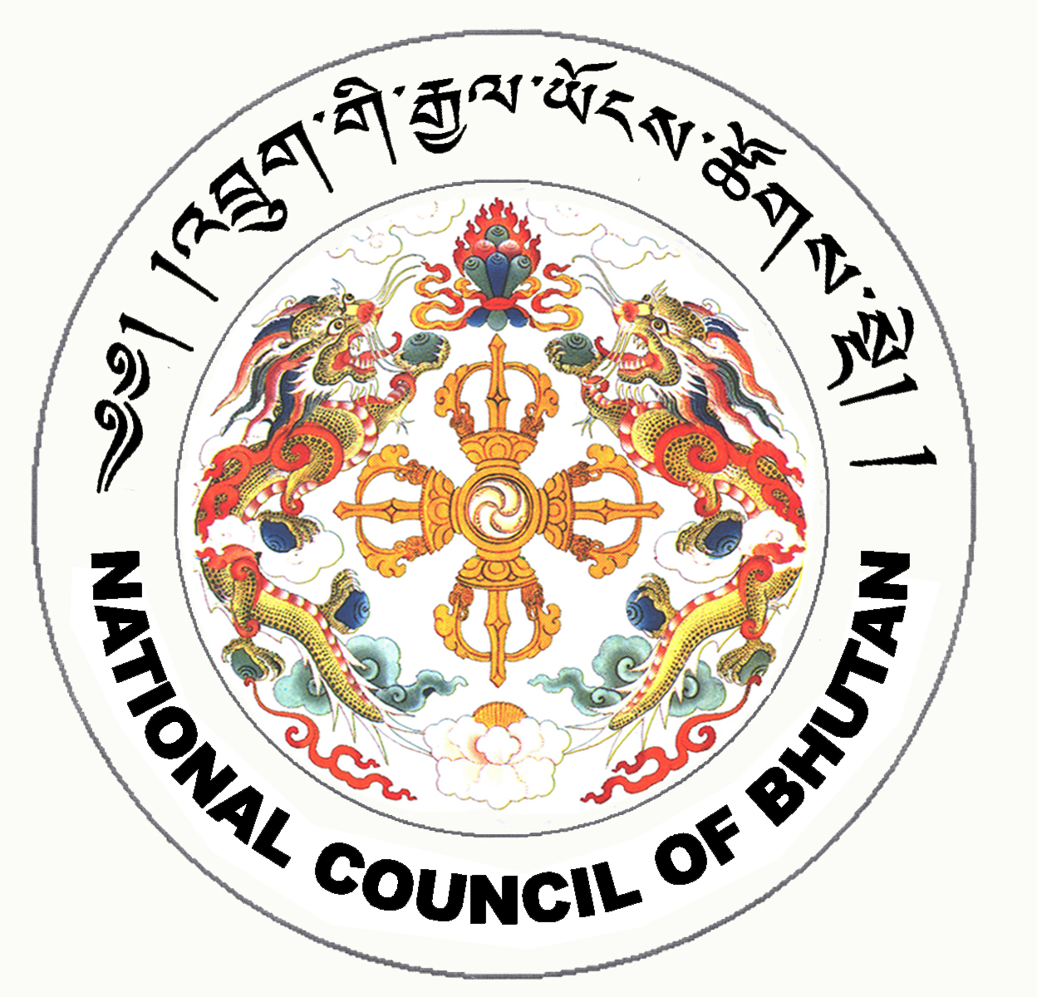

1st SESSION OF THE FIRST
NATIONAL COUNCIL OF BHUTAN
(10th Sitting)

ORDER OF BUSINESS
(Subject to change without notice)

1st July 2008 corresponding to 28th Day of first 5th Month of Earth Rat Year
09:30 – 13.00 hrs

09:30 hrs - Continue discussion on Budget and Re-appropriation Bill for the Financial Year 2008-2009.

11:00 hrs - TEA BREAK

11:30 hrs - Continue discussion on Budget and Re-appropriation Bill for the Financial Year 2008-2009.

13:00 hrs - Adjournment of Sitting

National Council Hall Sd/-
30th June 2008
(Tshewang Norbu)
Secretary General

