
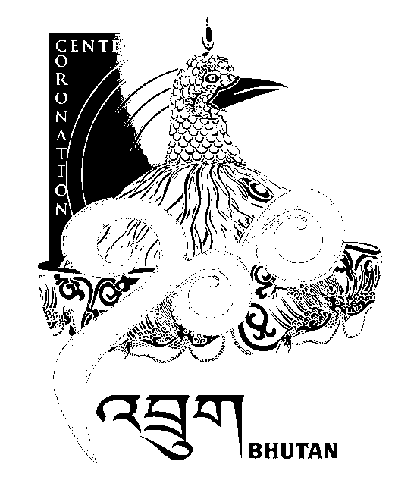
2nd SESSION OF THE FIRST
NATIONAL COUNCIL OF BHUTAN
(3rd Sitting)

ORDER OF BUSINESS
(Subject to change without notice)

Wednesday, 26th December 2008 corresponding to 29th Day of 10th Month of Earth Rat Year
09:30 – 13.00 hrs

09:30 hrs - Discussion on Land Compensation
10:00 hrs - Discussion on Human Wildlife Conflict
10:30 hrs - Discussion on Zhabto-Lemi
11:00 hrs to 11:30 hrs - TEA BREAK
11:30 hrs - Discussion on Youth Unemployment
12:15 hrs - Discussion on Rural & Agricultural Credit Schemes
13:00 hrs - Adjournment of Sitting

National Council Hall Sd/-
25th December 2008
(Tshewang Norbu)
Secretary General

