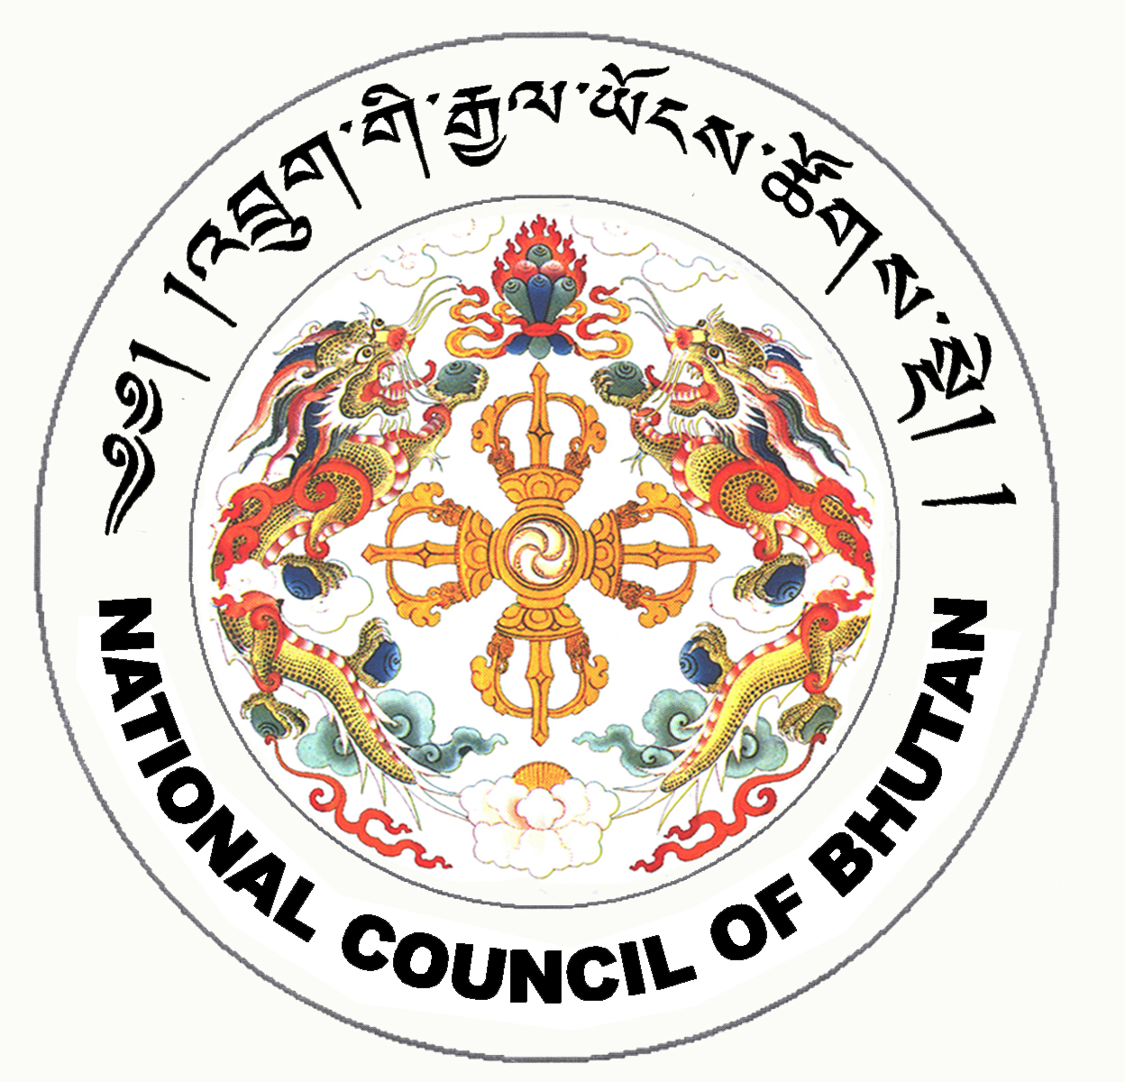
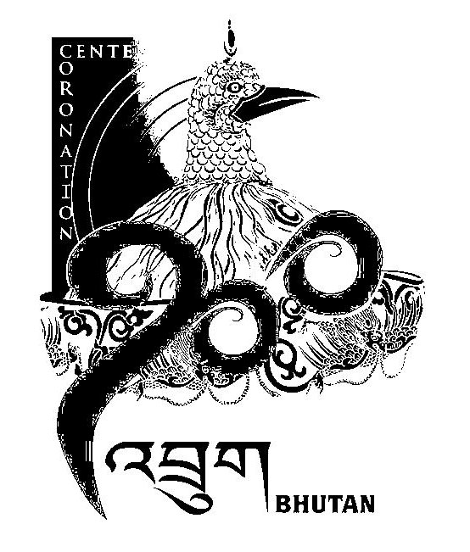
1st SESSION OF THE FIRST
NATIONAL COUNCIL OF BHUTAN
(6th Sitting)

ORDER OF BUSINESS
(Subject to change without notice)

25th June 2008 corresponding to 22nd Day of first 5th Month of Earth Rat Year
09:30 – 13.00 hrs

09:30 hrs - Continuation of discussion on the Election Bill of the Kingdom of Bhutan, 2008

11:00 hrs - TEA BREAK

11:30 hrs - Continuation of discussion on the Election Bill of the Kingdom of Bhutan, 2008

13:00 hrs - Adjournment of Sitting

National Council Hall Sd/-
24th June 2008
(Tshewang Norbu)
Secretary General

