
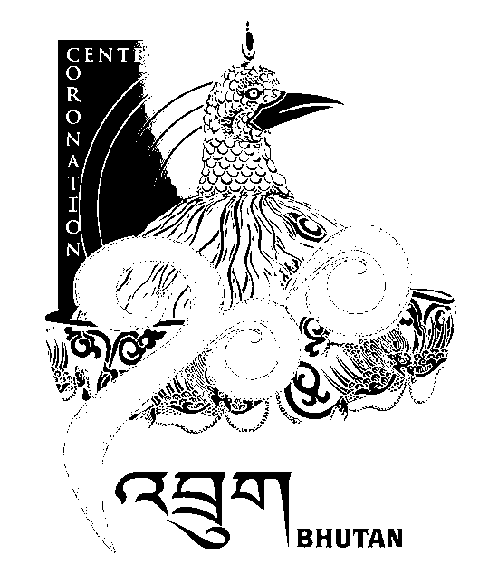
2nd SESSION OF THE FIRST
NATIONAL COUNCIL OF BHUTAN
(2nd Sitting)

ORDER OF BUSINESS
(Subject to change without notice)

Wednesday, 25th December 2008 corresponding to 28th Day of 10th Month of Earth Rat Year
09:30 – 13.00 hrs

09:30 hrs - Discussion on Impact of Mining on Environment
10:00 hrs - Discussion on Appointment of Caretaker for Gewog Centre
10:30 hrs - Discussion on National Minimum Wage

11:00 hrs to 11:30 hrs - TEA BREAK

11:30 hrs - Discussion on Remuneration for Chipons
12:15 hrs - Discussion on Wages and Remuneration for Gewog Officials

13:00 hrs - Adjournment of Sitting

National Council Hall Sd/-
24th December 2008
(Tshewang Norbu)
Secretary General

