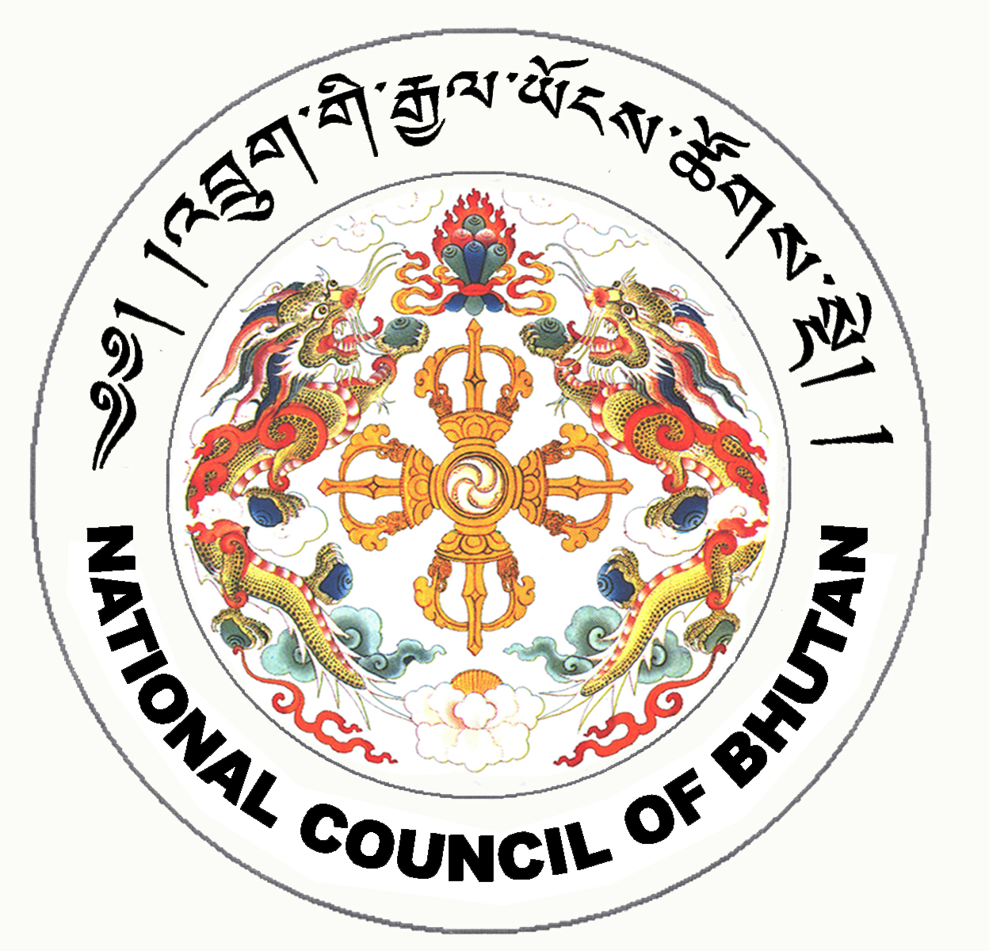
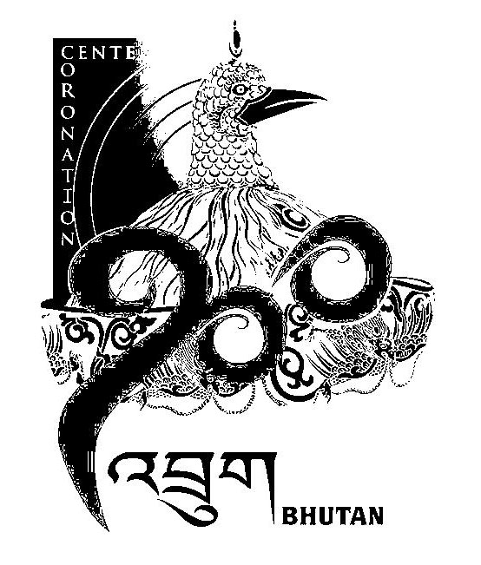
1st SESSION OF THE FIRST
NATIONAL COUNCIL OF BHUTAN
(2nd Sitting)

ORDER OF BUSINESS
(Subject to change without notice)

Wednesday, 19th June 2008 corresponding to 16th Day of first 5th Month of Earth Rat Year
09:30 – 13.00 hrs

09:30 hrs - Continuation of discussion on the Election Bill of the Kingdom of Bhutan, 2008

11:00 hrs - TEA BREAK

11:30 hrs - Continuation of discussion on the Election Bill of the Kingdom of Bhutan, 2008

13:00 hrs - Adjournment of Sitting

National Council Hall Sd/-
18th June 2008
(Tshewang Norbu)
Secretary General

