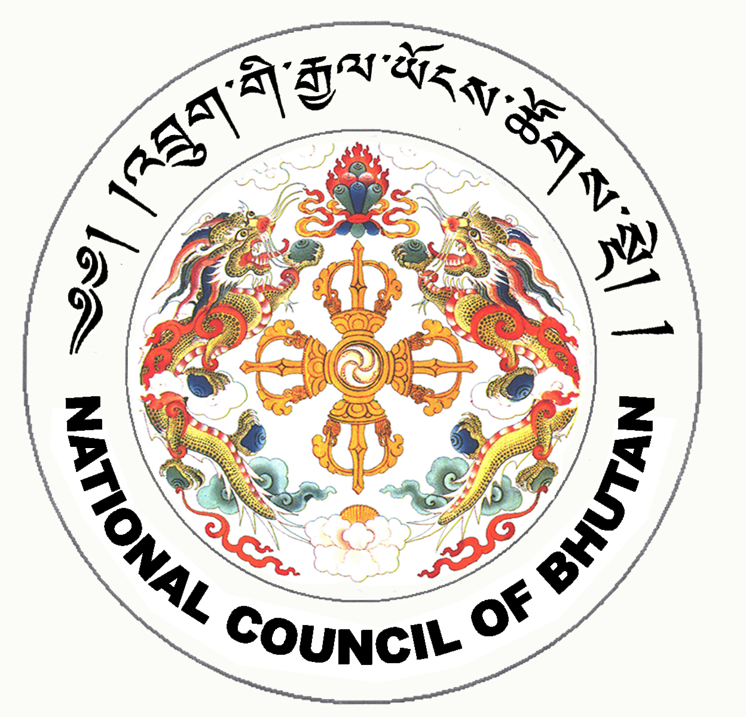
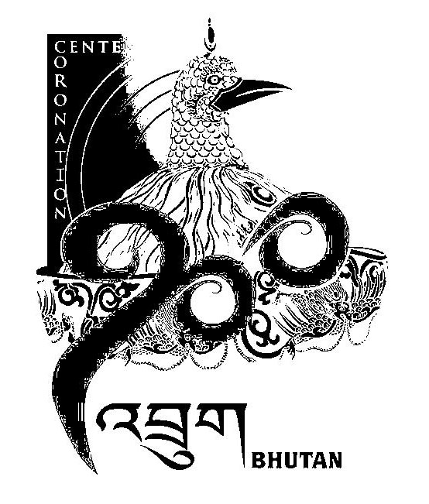
1st SESSION OF THE FIRST
NATIONAL COUNCIL OF BHUTAN
(1st Sitting)

ORDER OF BUSINESS
(Subject to change without notice)

Wednesday, 18th June 2008 corresponding to 15th Day of first 5th Month of Earth Rat Year
09:30 – 13.00 hrs

09:30 hrs - Tabling of the Election Bill of the Kingdom of Bhutan, 2008

- Chief Election Commissioner of Bhutan to take leave to introduce the Election Bill of the Kingdom of Bhutan, 2008

- Introduction of the Election Bill of the Kingdom of Bhutan, 2008

10:30 hrs - Discussion on the Election Bill of the Kingdom of Bhutan, 2008

11:00 hrs - TEA BREAK

11:30 hrs - Discussion on the Election Bill of the Kingdom of Bhutan, 2008

13:00 hrs - Adjournment of Sitting

National Council Hall Sd/-
17th June 2008
(Tshewang Norbu)
Secretary General

