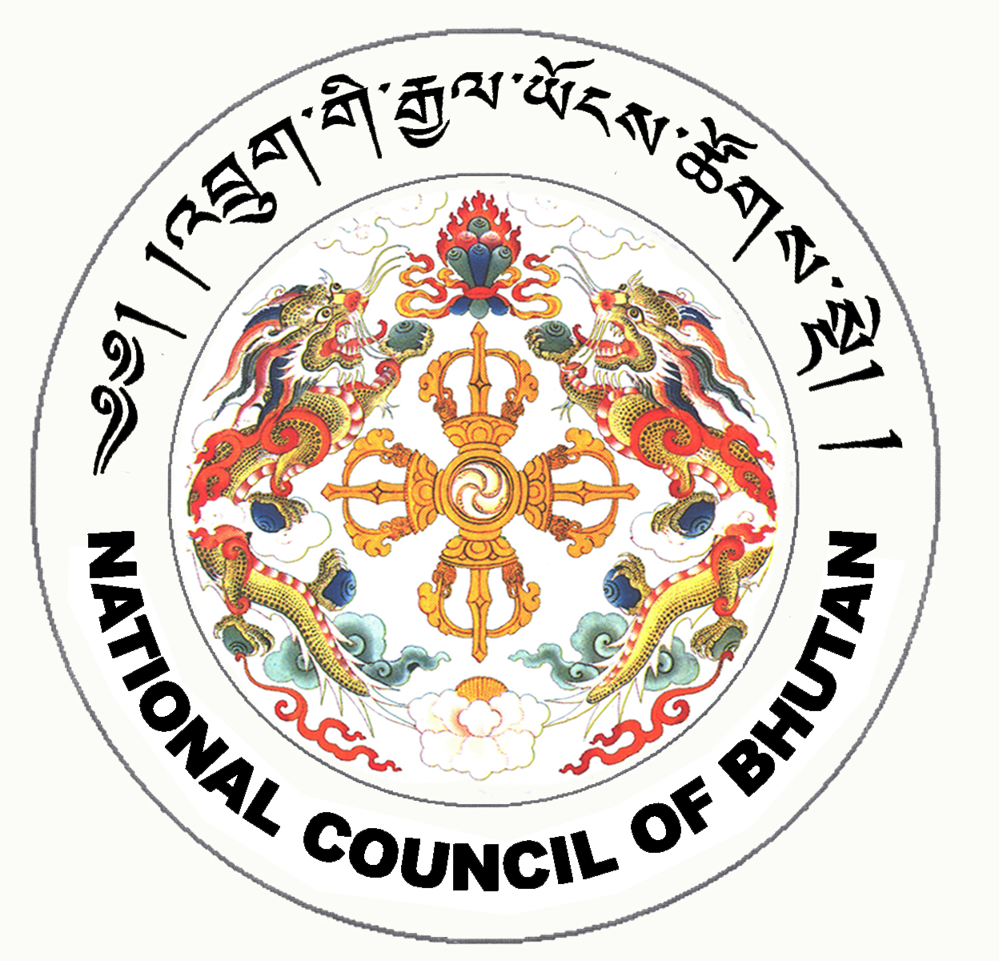
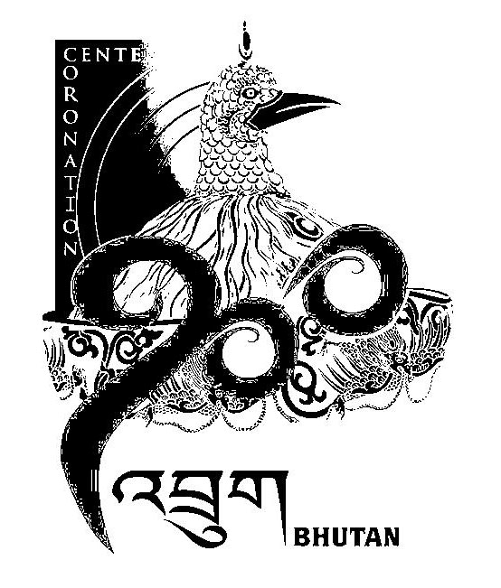
PROGRAMME FOR THE INAUGURAL SESSION
OF THE NATIONAL COUNCIL OF BHUTAN

Date & Time Programme

Date: 17th June, 2008
Day:Tuesday

08:30 hrs - All Members of the National Council assemble at the courtyard in front of the National Council Hall.

09:30 hrs - His Majesty the Druk Gyalpo to be received with Chibdrel procession

- Members of the National Council pay their respects to the Druk Gyalpo at the courtyard

- Members of the National Council enter the National Council Hall and remain standing in front of their respective seats

- His Majesty the Druk Gyalpo shall enter the National Council Hall and ascend the Golden Throne

09:45 hrs - Offering of Mendrel Kusung Thukten to His Majesty the Druk Gyalpo

- Zhugdrel Phunsum Tshogpai ceremony to be administered by Gyalpoi Zimpon

- Submission by the Chairperson

10:30 hrs - TEA BREAK

11:00 hrs - Adoption of Agenda for the Session

- Election Bill of the Kingdom of Bhutan, 2008
- Public Election Fund Bill of the Kingdom of Bhutan, 2008
- National Referendum Bill of the Kingdom of Bhutan, 2008
- National Council Bill of Bhutan, 2008

13:00 hrs - Adjournment of Sitting

